**Looping on Array**

You can loop the elements of any array by using looping statements.

**Example:**

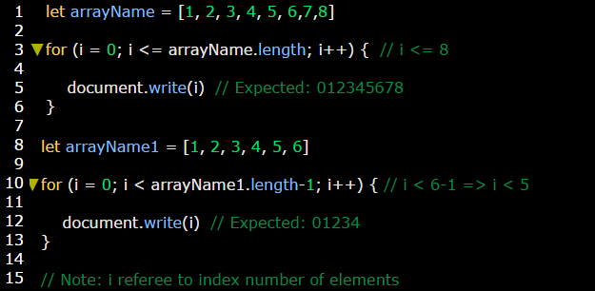

**Example 2:** looping by using **for of** statement loop.

